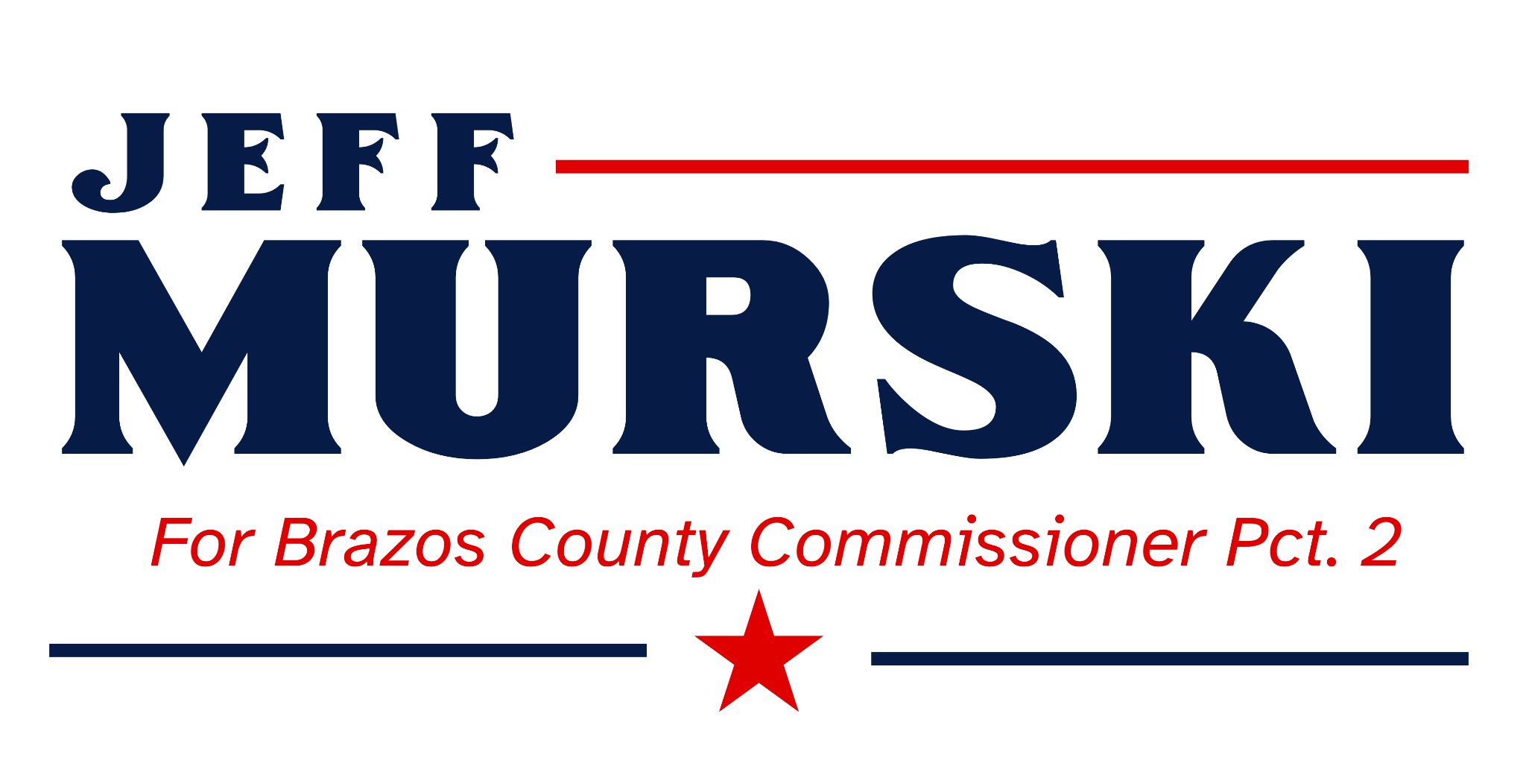 CONTACT: Jeff Murski
murskiforbrazos@gmail.com
FOR IMMEDIATE RELEASE
Monday, July 7, 2025

Congressional Staffer Jeff Murski Announces Intent to Run for Brazos County Commissioner, Precinct 2

BRAZOS COUNTY, TX - Jeff Murski, longtime Outreach Coordinator for Congressman Pete Sessions, issued the following statement regarding his bid for the office of Brazos County Commissioner Precinct 2.

‘As a resident of Precinct 2 for over 25 years, I have raised a family and developed many meaningful relationships over the years which have enabled me to better understand the values and needs of our county. Recently, I and many others have witnessed questionable decision making and a growing perception that points to a lack of transparency by our county government. This seems to be working against the trust between the voters and the elected officials.

As a Congressional Staffer, I have developed and enjoy meaningful and effective relationships with many County Judges, Commissioners and Sheriffs throughout TX-17 learning about their communities’ needs and helping them. I am confident that I am better equipped and qualified to represent the citizens of Precinct 2, to service their needs and advocate for them. I will focus on these four areas;

- Taxes: The Court has raised our taxes. It has been demonstrated that our growth can sustain our immediate needs without raising taxes. Two years ago, a ‘No New Tax Revenue Rate’ was adopted by the Court. The County still ended up with a $21M surplus. I will work hard to show the Court that we can achieve our financial goals by keeping our tax rate as low as possible. The taxpayer expects this, and I will work hard to deliver.
- Advocacy: I will treat this position as my full-time job for which the County compensates each Commissioner. Servicing your needs is important to me. I will make myself available to you and return phone calls in a reasonable amount of time. I will also work with the Court and Staff to get the aging, out of date, 17-year-old phone system replaced as soon as possible.
- Operational efficiencies: It is easy to go after taxes; it is hard to go after efficiencies. I will do my very best to help the Court and Staff discover new ways to save money by cutting red tape and incentivize County employees to foster a positive and productive work environment.
- Transparency and Priorities: Based on recent feedback by Precinct 2 constituents, our elected officials have chosen many times to focus on their wants and not on the needs of the taxpayer. I will propose measures through votes on the Court for more accountability, improved communications and a re-evaluation of county project priorities and funding. I am against the East Loop Project.

I want to help make Brazos better again. I want to FIX, not FIGHT. I am determined to help our County Government function better and govern well.

Today is the day that we re-commit, work together, share our values and ideas to make this a better place to live and raise a family and/or run a business. It is our responsibility as citizens to elect someone who is determined to rectify the situation at hand. I stand ready to earn your vote and follow through with integrity, honesty and with YOUR best interests at heart, not just for one family, faction or entity.

For more information about my campaign, schedule an interview or host a meet and greet, please email me at murskiforbrazos@gmail.com . In the coming weeks, my website will go live and my teams’ plan will go into action reaching out to you and your neighbors. I covet your prayers and ask for your vote. March 3, 2026, will be here before you know it.
God Bless Brazos County.

